

# EventMate

Software Engineering & Big-data modeling,

Plan-Driven and Agile Programming

TEI Crete, Winter semester 2018/2019

Authors: Petra Cendelínová, Petr Kalas

EventMate 1

1. System specification 3

1.1. Introduction 3

1.2. Description 3

1.3. Requirements 4

1.3.1. Requirements list 4

1.3.2. Requirements diagram 5

1.4. Mindmap 5

1.5. Use Case 5

1.5.1. Use case diagram 5

1.5.2. Use case details 6

1.6. State machine diagram 8

1.7. Mockups 11

1.7.1. Event owner (Android) 11

1.7.2. Event owner (web) 11

1.7.3. Event assignee 12

2. Architecture design 12

3. Appendices 14

3.1. Attachment 1 – Use case diagram 1

Attachment 2 – Mindmap 2

## System specification

## Introduction

For human beings, it is natural to socialize and interact with each other. Technology has become more and more important in the social aspects of life. Nowadays people prefer to spend more time on portable devices. Social networking has moved to mobile platforms, which are accessible anywhere and anytime.

The objective of our work is to develop a social application for organizing events any type. As events can be considered birthday parties, new year eve, weddings, baby showers etc.

As we want to make this application more general for any kind of events, we have decided to call it by name “EventMate”. The main goal of the application is to provide tasks management (create, assign, close) and also to create a communication channel among event owners and guests. The application is going to content gamification elements such as a scoreboard and badges.

## Description

The following chapter explains major features. In order to use the application it is necessary to create a user's account or log in via existing social accounts. In our application, there are various user roles such as owners, assigness, guests. As we mentioned earlier, the main goal is to provide task management for an event. For all practical purposes, it means that user can create a task with corresponding attributes such as name, deadline, and persons to be assigned to it. All these fields are saved and continuously maintained. During the whole event, gamification principles are applied which help users to feel that they are a part of the game. When the event has finished, event summary is provided to particular users.

**List of roles**

**Event owner** – it is considered as a user that has created an event. Event creation gives this user all permissions to manage event such as edit, delete, lock, start and close.

**Task owner** – it is a event guest that has created a task. As its owner has a right to edit, delete, start (in case of time limit task), assign points to assignees and close task. Task owner can also assign his own task to himself.

**Assignee** – it is a type of user that has been assigned to a particular task. He has a right to upload his answers and view results of others.

**Guest** – it is a regular user that has been invited to an event. He hasn’t created any task yet or assigned to any task. He can view event detail with its tasks.

## Requirements

This section describes requirements for EventMate application.

## Requirements list

In this section there are listed all functional and also non-functional requirements.

* + - 1. Functional requirements
* User registration
* User registration via Facebook / Google account
* User login
* Create events
* Create events from template
* List events
* Filter events
* Modify events
* Delete events
* Chang event state
* Create tasks
* List tasks
* Modify tasks
* Change task state
* Submit task results
* Edit task photo
* Assign points for accomplished tasks
* Create reports
* Share reports
* Send private messages
* Send group messages
* Show user profile
* Change their own settings
* Setup notifications
  + - 1. Non-functional requirements
* Supported Android version 6 – 8
* Supported Web version by all browsers
* Responsible Android frontend
* Responsible Web frontend
* Android app available in portrait mode
* General usable REST API
* Secured REST API
* Android app capable of working in offline mode
* Ownership permission policy
* Maximum response time of 2 seconds
* Multiplatform backend support
* Log rotation ability
* Account password encryption
* Multilanguage support

## Requirements diagram

Fig. presents requirements diagram.

## Mindmap

Created mindmap for this apliccation can be found in Appendix 2.

## Use Case

The following sections describes use case diagram with two actors. The principal use cases are described in detail. Particulary speaking about creating a new event, adding a new task and generating event summary.

## Use case diagram

## Use case details

Figure 1 - Add task user case detail

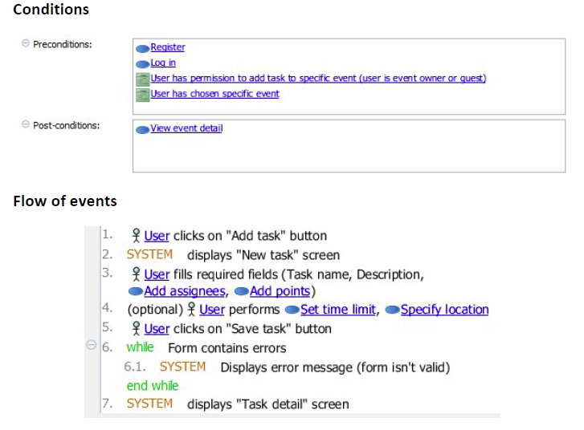

TODO prehodit

Figure 2 - Create event use case detail

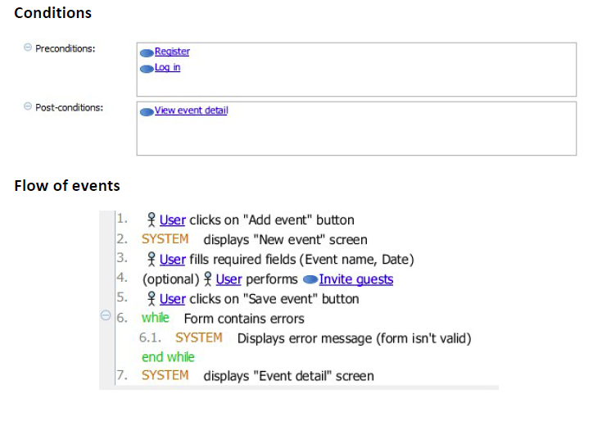

Figure 3 - Generate event summary use case detail

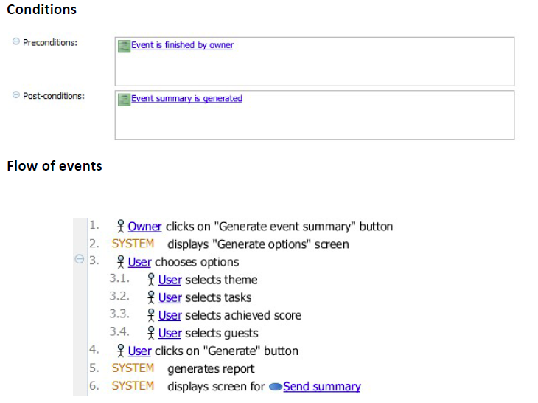

## State machine diagram

The aim of this section is to clarify possible states of events and tasks using state machine diagram.

Firstly, event states will be presented. Any event can exist in four states. After its creation it is considered as ‘editable’ state. During this phase any user can add a new task to this event. Later on, the event owner has a right to lock his event to prevent guests from adding new tasks. Afterwards, the event owner is entitled to trigger his own event. The state is known as ‘in play’. The event can changed its state to ‘finished’ when the owner close it or assign points for all tasks.

Figure 4 - Event state diagram

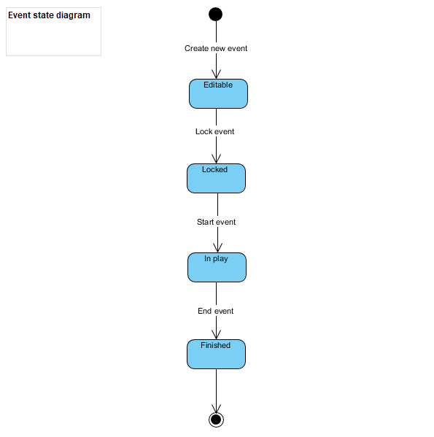

The application supports two types of tasks. Particulary speaking about tasks without defining time to finish and tasks with specified time limit. After its creation a task becomes editable. When its parent event has been triggered, the task passes to a new state ‘In play’ which supports result submission for assigned users. After submission of results or stopping the task by its owner, the task becomes only readable known as ‘In review’ state. Transition to last state requires granting points to assignees done by the task owner.

Figure 5 - Task state diagram

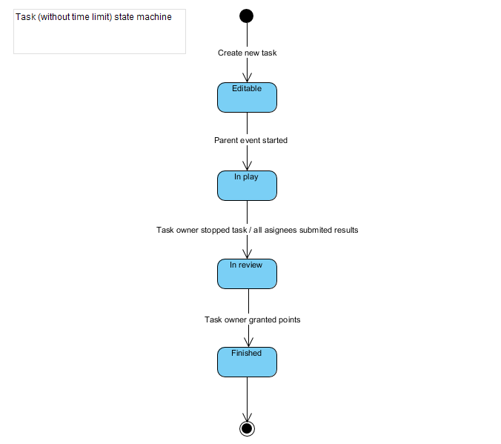

As Fig. 6 shown tasks with defined time limit contain one state more named ‘Ready to start’. Transition to next state requires activation by its owner.

Figure 6 - Task (time limited) state diagram

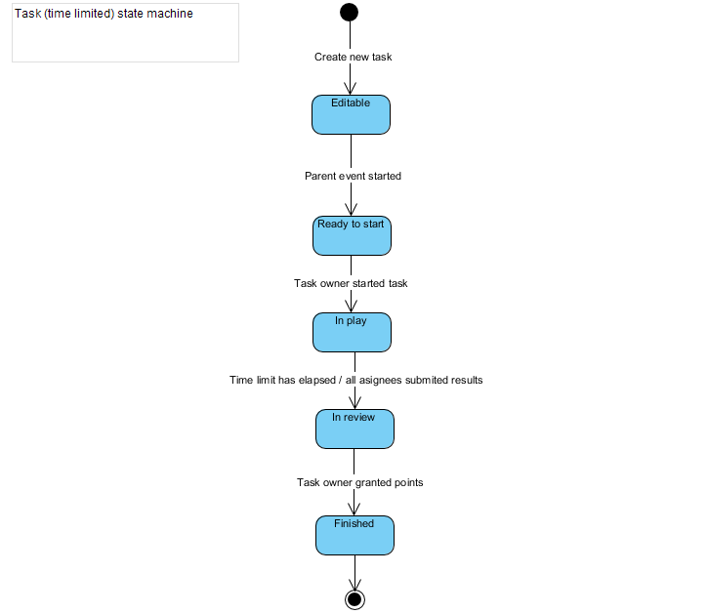

## Mockups

asda

## Event owner (Android)

asd

## Event owner (web)

asd

## Event assignee

asd

## Architecture design

Architecture style is based on **client-server.** The project consists of two client side parts and server side with a database.

* 1. Component diagram
  2. Architecture diagram

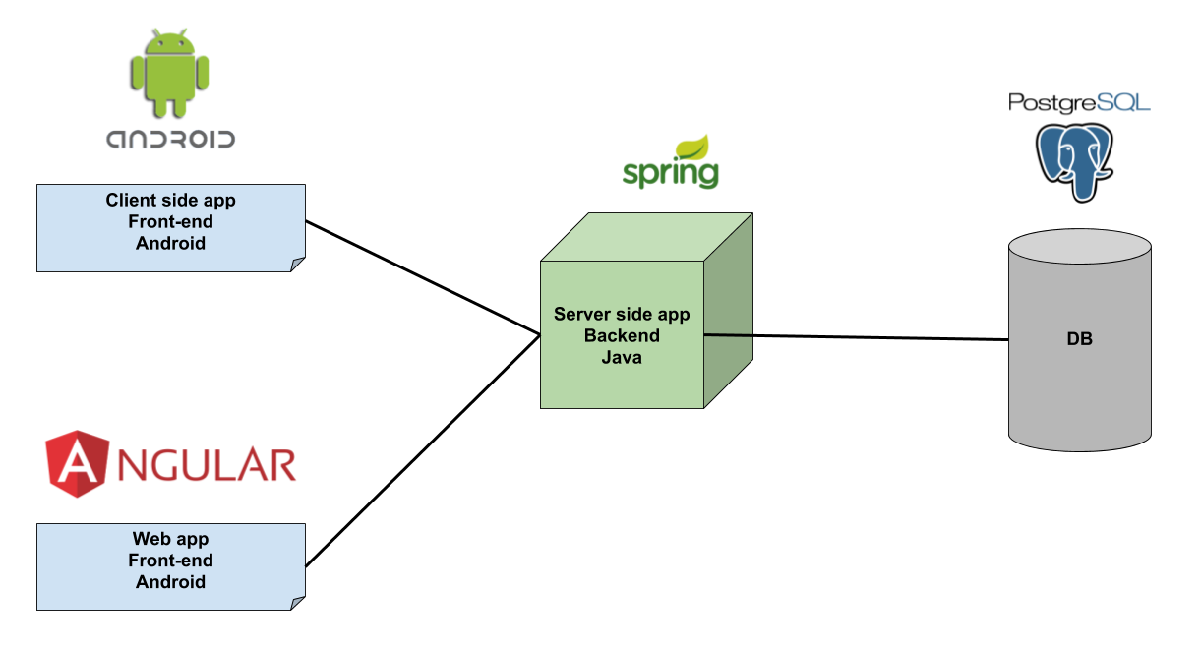

**Server side**

Purpose of server-side application is to provide API, user authentication and persistence to the client side. The asynchronous notification system will be also provided by the server side.

Technology stack (early version)

* Java
* Spring Framework
* PostgreSQL

**Client side**

**Client side - Android**

First type of client-side is going to be implemented as a native mobile application for platform Android There will be a huge emphasis on UX (User experience) and also on gamification techniques. Android application is going to adhere MVVM architecture that allows separating the user interface logic and the business logic.

Technology stack

* Kotlin
* LiveData
* Library Retrofit for API calls
* Dagger for dependency injection

**Client side – Web**

Another type of client-side is going to by implemented as a web application based on Angular framework.

Technology stack

* Angular 6 framework

TODO:

Chapter 1 – system specification (diagrams..)

Description, requeiremnts list + diagram, textual description, use case diagram, mockups, short description,

Chapter 2 (Architecture design (title))

- Component diagram

* Architecture diagram

Prezentace

* + - 1. Slide – mockup
      2. Slide – req. diagram
      3. Slide – use case diagram

## Appendices

## Attachment 1 – Use case diagram

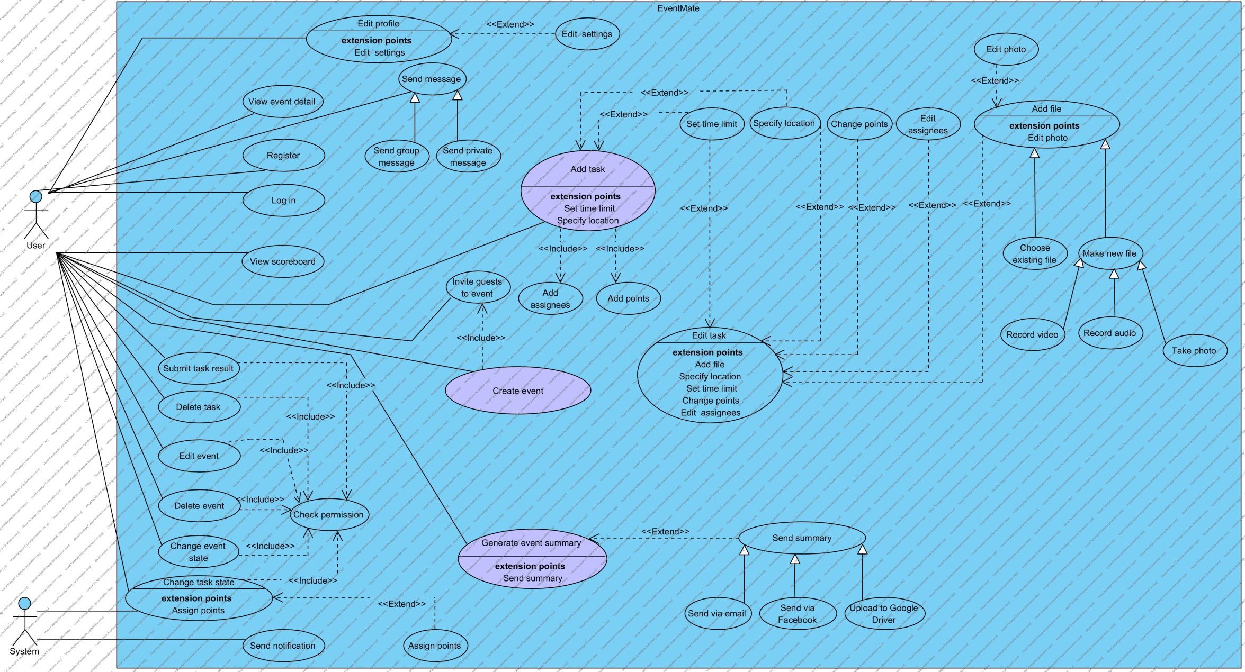

## Attachment 2 – Mindmap

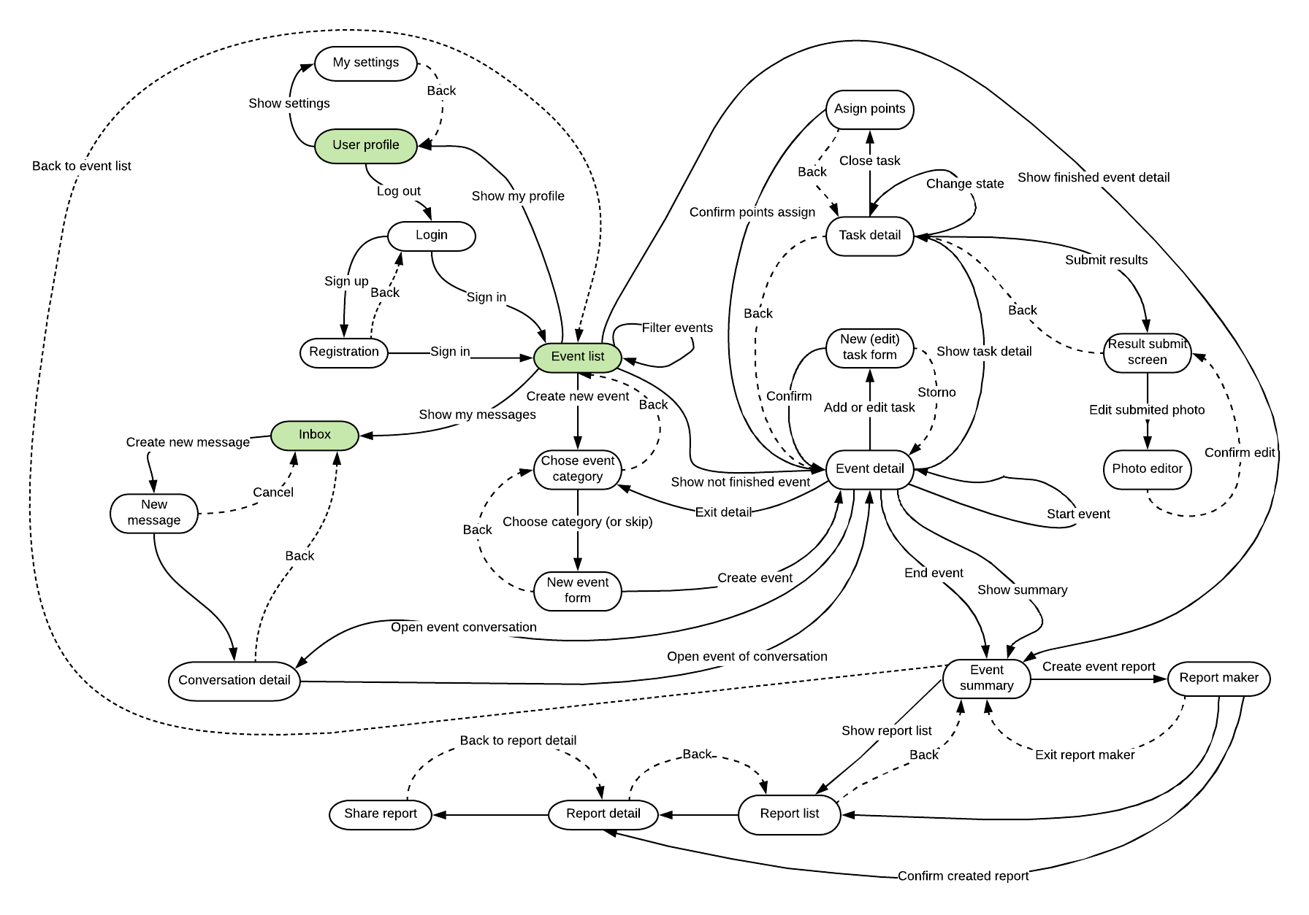

## Attachment 3 – Mindmap

Attachment 4 – Mockups: Event owner role (Android)

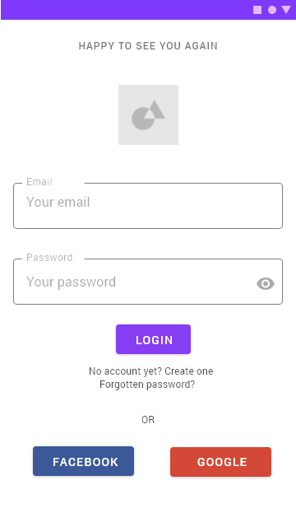 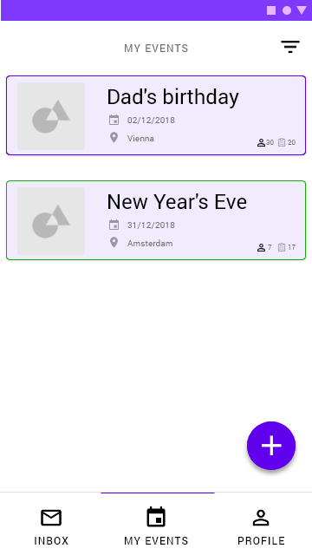 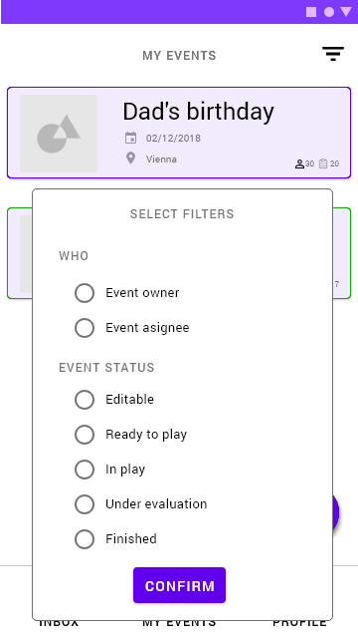 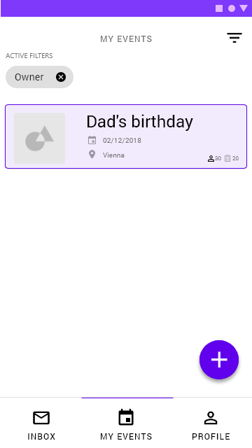 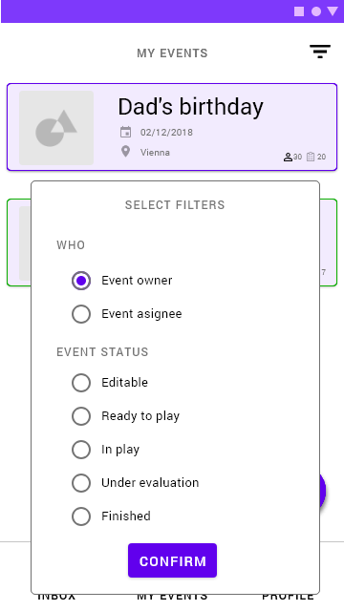 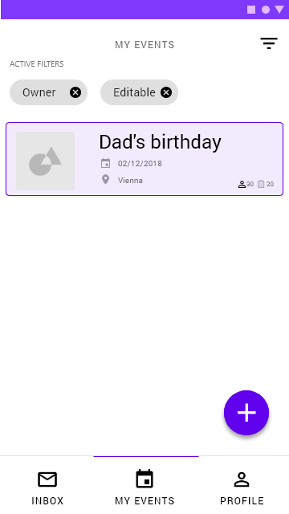 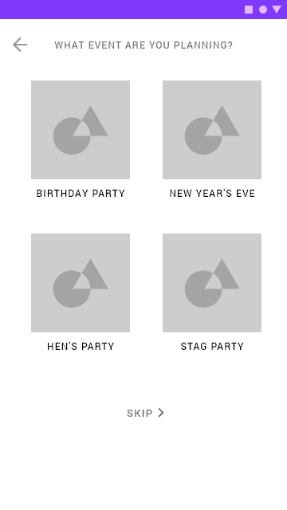 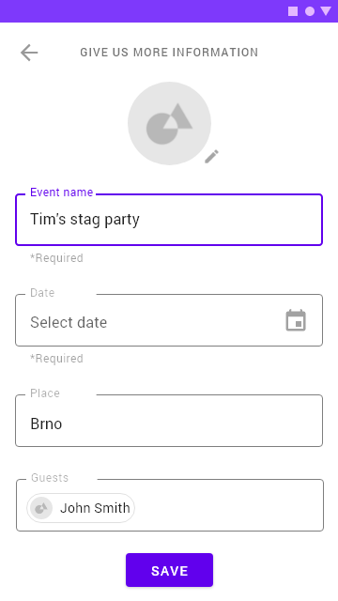 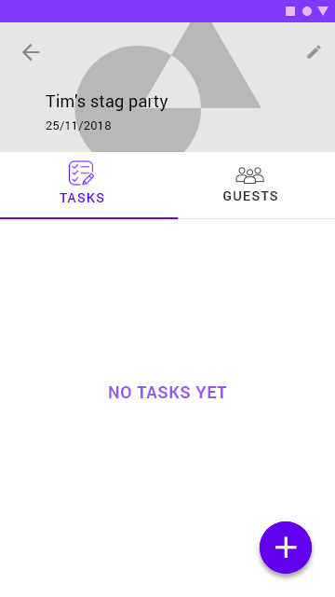 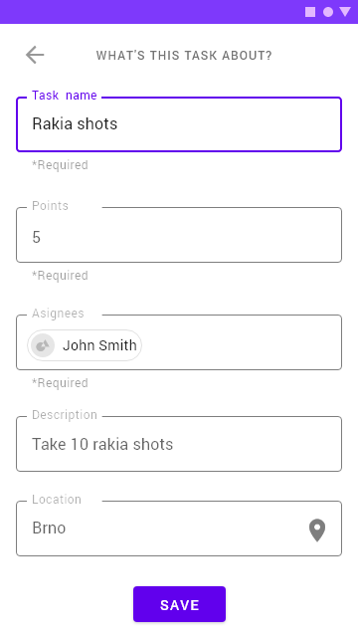 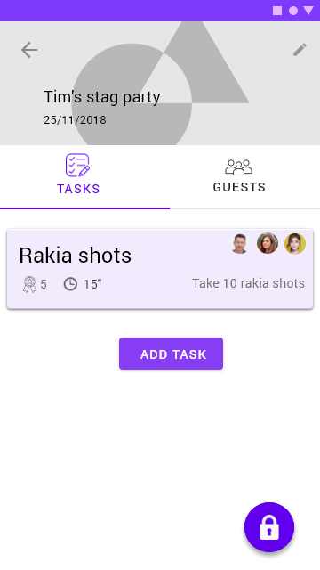  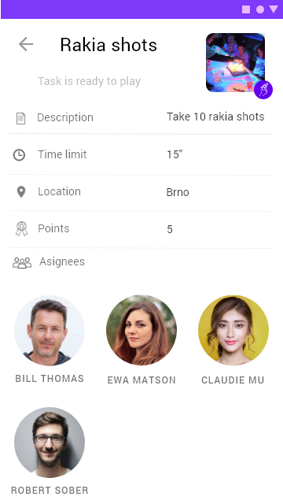 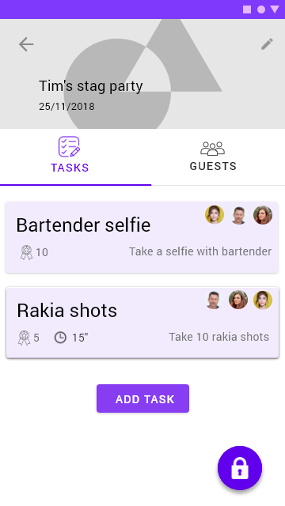 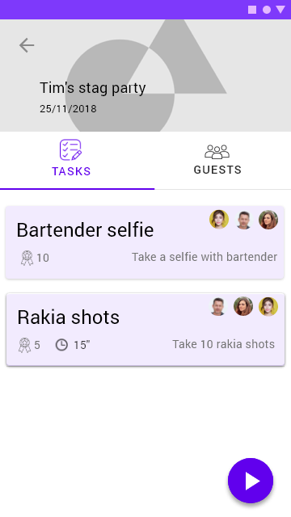 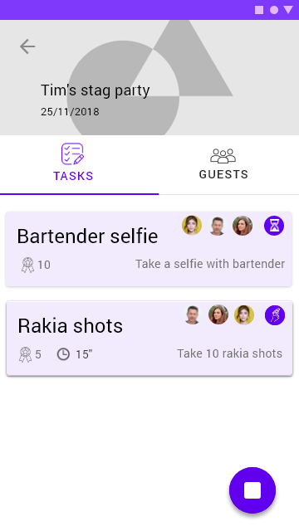 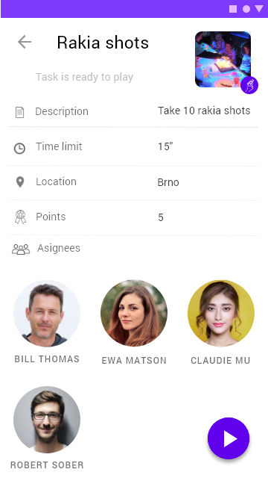 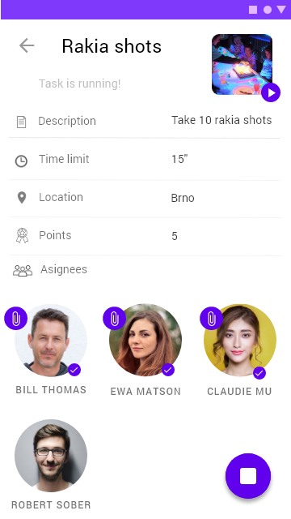 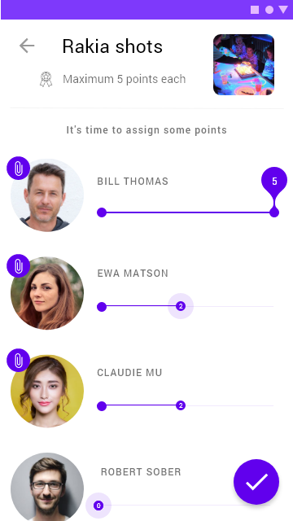 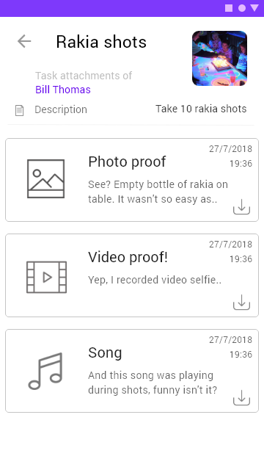 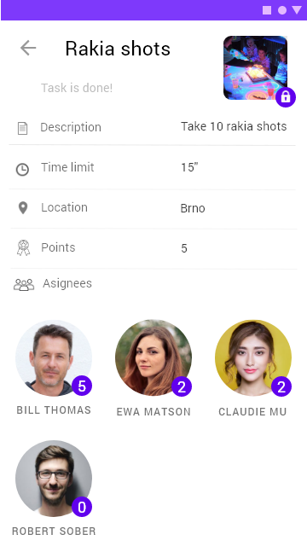 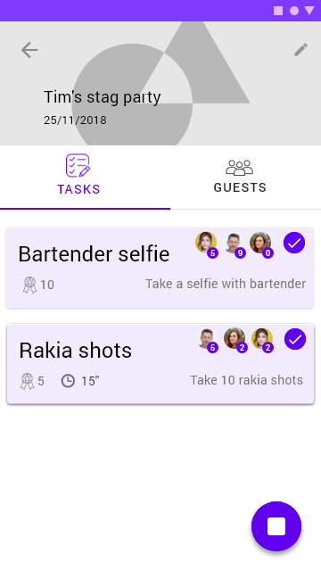 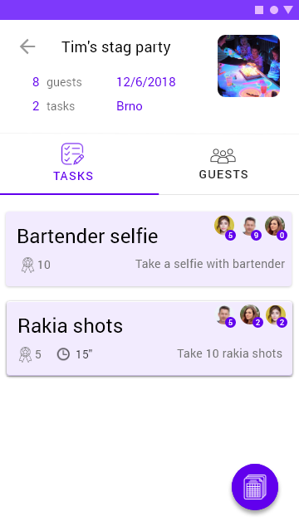 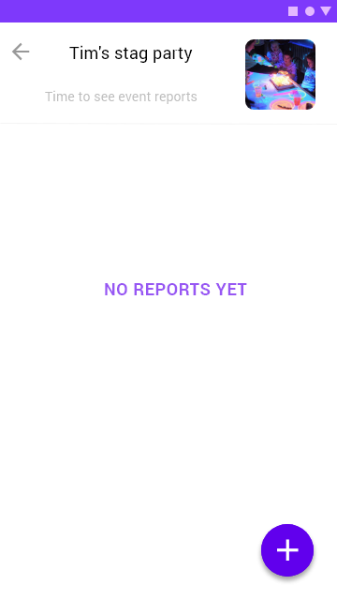 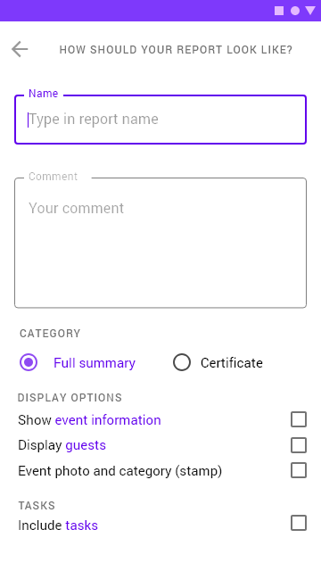 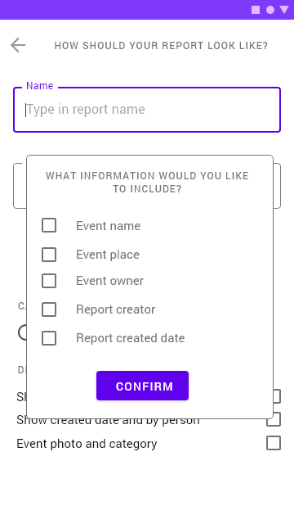 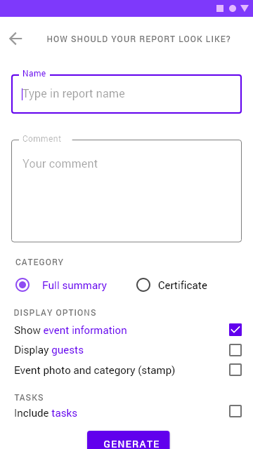 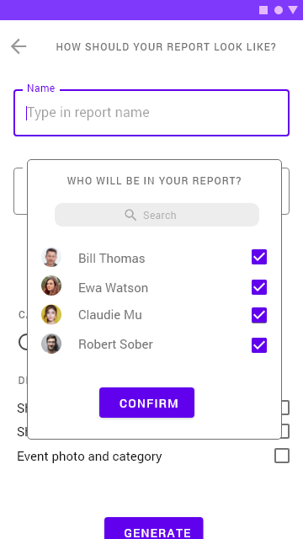 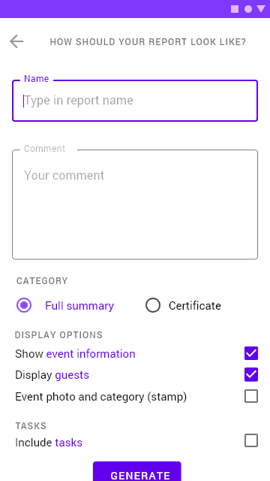 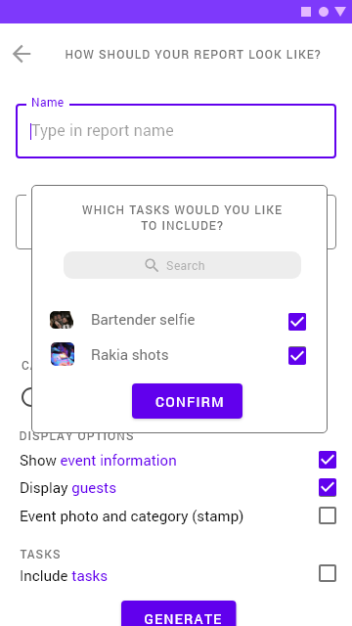 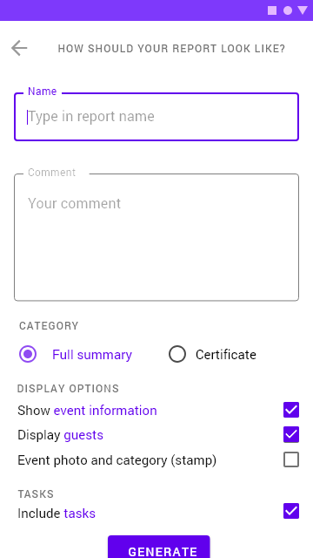 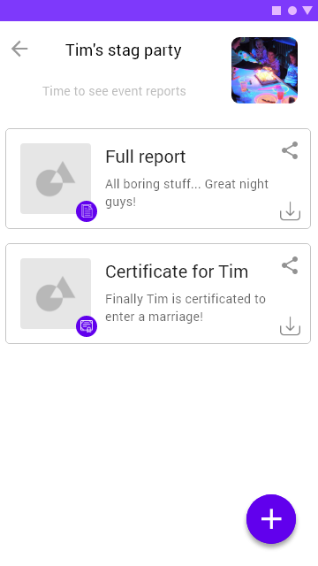 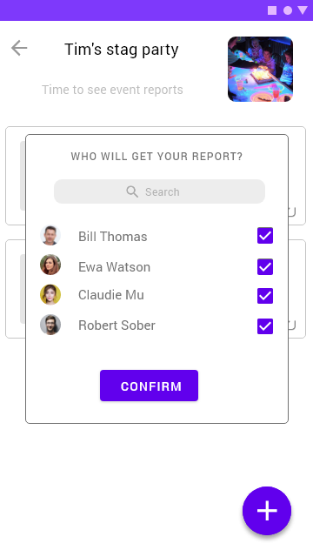 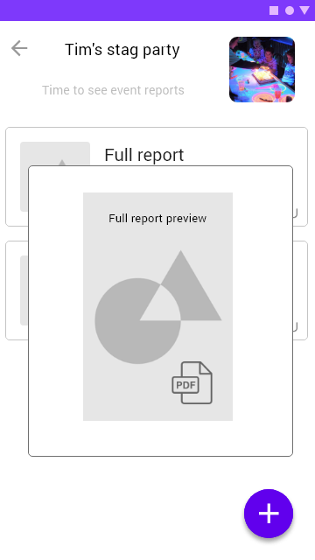

ddsf